Problem Statement
We have a requirement to create a form through which the users can request the finance department for making a vendor payment. The flow would be like below 1. User clicks on a link which opens a form (preferably Power Automate) 2. Fills the required details like a. Vendor Name b. Vendor Code c. Invoice Number (not mandatory as the user may request for an adhoc payment) d. Invoice Amount / Requested payment amount Once he fills up the form, it goes through approvals and once this gets approved by the final approver, it should go to D365 and creates vendor payment journal with the details already in the form. Please help me with some solution or workaround to achieve this

A[User clicks link] --> B[Open Power Automate form]
B --> C[User fills form]
C --> D[Form submitted]
D --> E{Approval process}
E -->|Rejected| F[Notify user of rejection]
E -->|Approved| G[Create vendor payment journal in D365]
G --> H[Notify user of approval and journal creation]
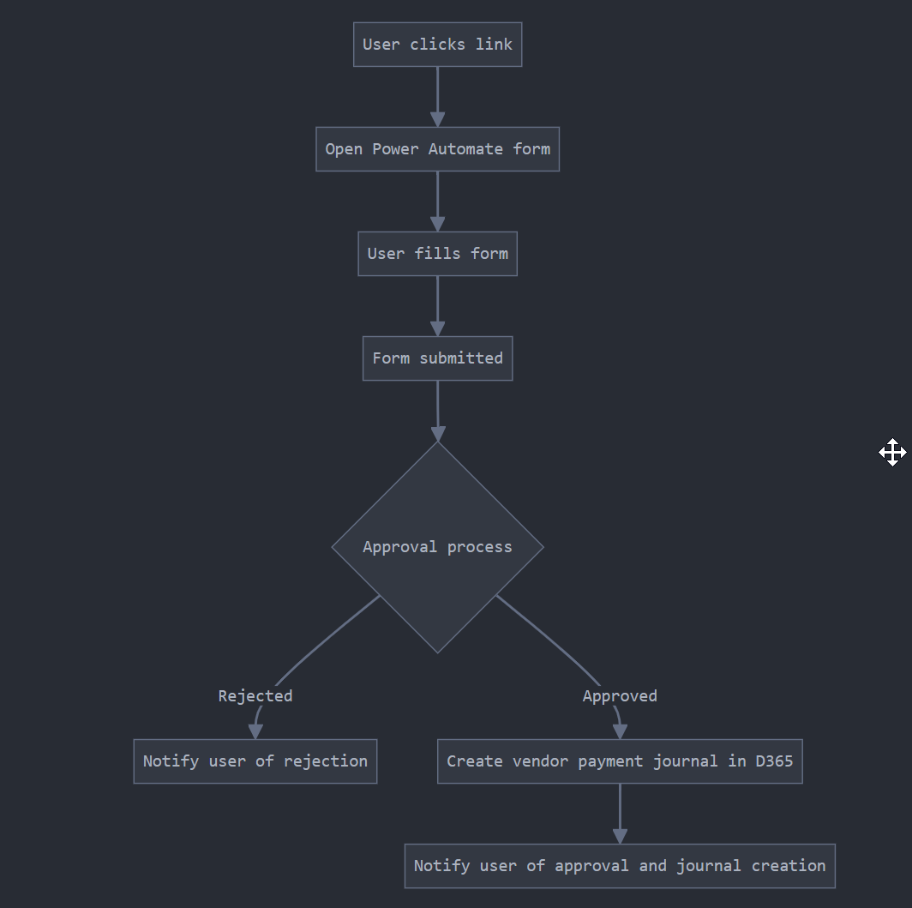

Now, let's break down the solution into steps:
- Create a Power Automate flow:
  - Start with a "PowerApps trigger" or a "When an HTTP request is received" trigger.
  - Design a form with the required fields (Vendor Name, Vendor Code, Invoice Number, Invoice Amount).
- Set up the approval process:
  - Use the "Start and wait for an approval" action in Power Automate.
  - Configure multiple approval levels if needed.
- Integrate with Dynamics 365 Finance:
  - After final approval, use the Dynamics 365 Finance connector in Power Automate.
  - Create a "Create record" action to generate a vendor payment journal.
- Notification system:
  - Add "Send an email" actions to notify the requester of approval status and journal creation.
To implement this solution, you'll need:
- Microsoft Power Automate license
- Dynamics 365 Finance license
- Proper permissions and connections set up between Power Automate and D365

Here's a more detailed breakdown of the Power Automate flow
Power Automate Flow: Vendor Payment Request
- Trigger: PowerApps or HTTP request
  - Collect form data (Vendor Name, Vendor Code, Invoice Number, Invoice Amount)
- Initialize Variables:
  - Set ApprovalStatus to "Pending"
  - Set CurrentApprover to first approver's email
- Start Approval Loop:
  - Condition: While ApprovalStatus is "Pending"
    - Action: Start and wait for an approval
      - Assign to: CurrentApprover
      - Details: Include all form data
    - Condition: If approved
      - Update ApprovalStatus to "Approved" if final approver
      - Otherwise, update CurrentApprover to next approver's email
    - Else:
      - Update ApprovalStatus to "Rejected"
      - Send rejection notification to requester
      - Terminate flow
- Create Vendor Payment Journal in D365:
  - Use "Create record" action with D365 Finance connector
  - Map form fields to D365 journal fields
- Send Confirmation:
  - Notify requester of approval and journal creation
  - Include journal details and next steps
- End Flow

To implement this solution:
- Set up the Power Automate flow as described in the artifact.
- Create a PowerApp or a simple webpage with a link that triggers the flow.
- Configure the Dynamics 365 Finance connector in Power Automate.
- Set up appropriate security roles and permissions in both Power Automate and D365.
Some considerations and potential challenges:
- Ensure data validation in the initial form to minimize errors.
- Handle scenarios where the vendor or invoice doesn't exist in D365.
- Implement error handling and logging throughout the flow.
- Consider how to handle partial approvals or modifications to the request during the approval process.

